# DS 620 – Data Visualization Assignment Week 7

**Points: 100**

1. **Evaluating the Design of a Data Dashboard**. An alternative version of the Espléndido Jugo y Batido data dashboard shown in Figure 8.12 follows. How would you modify this alternative to improve the dashboard?

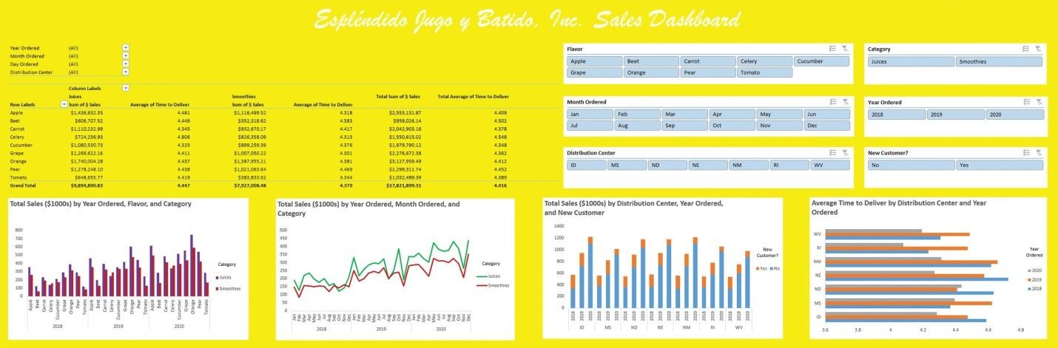

Solution:

* Since we are looking at locations, having a geographical map would be more sensible
* We can also add pie charts to make comparisons between different attributes
* Adding Scorecards can help users of the dashboard grasp focused information at a glance
* Dividing visualizations for New & Existing customers.
* From a business standpoint, the above image lacks Quarterly Breakout of the numbers, adding a couple of charts for that, would give insights for better strategic decisions.

Above mentioned recommendations can be performed on Power BI and can be automated, VBA for Excel and python for more advanced & large-scale implementation.

**Building a Donor Data Dashboard**. The American Retriever Foundation (ARF) is a not-for-profit organization dedicated to health issues faced by the six distinct retriever breeds (Chesapeake Bay, curly- coated, flat-coated, golden, Labrador, and Nova Scotia duck tolling). ARF needs to develop a data dashboard to monitor its donor activity and its interactions with potential donors. Management is concerned primarily with the number and dollar value of donations, the number of legacy donors (those who have donated in the past twelve months) and new potential donors solicited, and the number of solicitations that result in donations. They want to compare these results across ARF’s four development officers (Randall Shalley, Donna Sanchez, Marie Lydon, and Hoa Nguyen) by date and mode of contact (telephone, email, or personal meeting).

ARF has collected data for each solicitation initiated last year from its relational database. These data include the solicitation number, development officer, date of solicitation, mode of solicitation, whether the solicitation resulted in a donation, and whether the solicited potential donor was a legacy donor. ARF also added a field for month in which the solicitation was made.

ARF’s staff has already created the following components for the data dashboard in Excel.

* + A stacked bar chart of the number of solicitations across development officer by whether the solicitation resulted in a donation (in the *Chart1* worksheet)
  + A stacked bar chart of the percentage of successful solicitations across mode of

solicitation by whether the solicitation resulted in a donation (in the *Chart2*

worksheet)

* + A stacked bar chart of total donations (in $1000s) across development officer by legacy designation (in the *Chart3* worksheet
  + A cluster bar chart of total donations (in $1000s) across mode of solicitation by legacy designation (in the *Chart4* worksheet)

The data and these charts are available in the file *ARFCharts*, and the name of the worksheet in which each chart can be found is given with the descriptions of the charts ARF has developed. LO 6

Create the following for the charts created by ARF.

* + - A slicer for development officer, a slicer for whether the solicitation resulted in a donation, and a slicer for month of solicitation for the chart in the *Chart1* worksheet

* + - A slicer for mode of solicitation, a slicer for whether the solicitation resulted in a donation, and a slicer for development officer for the chart in the *Chart2* worksheet

* + - A slicer for development officer, a slicer for legacy status of the donor, and a slicer for month of solicitation for the chart in the *Chart3* worksheet

* + - A slicer for mode of solicitation, legacy status, and month of donation for the chart in the *Chart4* worksheet

PS: MS EXCEL FILE IS ATTACHED ALONG THE SUBMISSION TOO